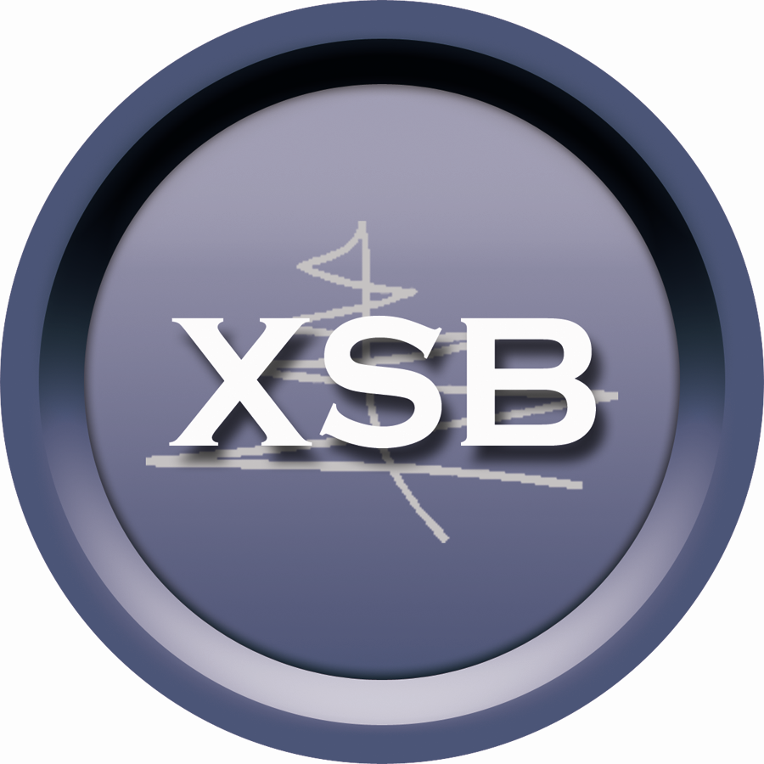

Government Business Intelligence Services

Proposal for Government Contract Services, Inc.

Submitted By:

XSB, Inc.
21 Bennetts Road – Suite 100
Setauket, NY 11733
Phone - 631-371-8102
Fax - 631-382-8228
www.xsb.com

31 January 2017

XSB Government Business Intelligence Services

I – Company Background:
XSB, Inc. is a small business and GSA MAS IT70 contract holder. We provide software and services for component product search, selection and management to large government and commercial buying organizations. Our patented parts data management and semantic web-based solutions turn the poor, inconsistent parts data found in enterprise applications into an integrated network of concepts that coherently represent the important relationships among parts used by the enterprise and its suppliers. We do this by integrating legacy data with rich external content.

XSB has developed and licenses a number of Web based applications to assist enterprises in reducing the costs associated with product selection, fair market pricing, inventory reduction, item obsolescence and regulatory compliance. Customers include the United States Department of Defense (DOD) and United States General Services Administration (GSA) as well as a number of Fortune 100 companies and small independent suppliers in the public procurement market.

II – Capabilities:
The A&D supply chain is one of the largest and complex in existence today, containing tens of millions of products offered by thousands of suppliers. Product data, in the form of descriptions associated with manufacturer names and part numbers, do not follow any standard; they are full of jargon and abbreviations, and differ in information richness. This lack of standardization between suppliers and data sources makes it difficult to find identical parts across the supply chain, assess pricing, regulatory conformance, and perform other important procurement related activities.

To illustrate the situation, we can look at sample data from a single GSA MAS catalog available on GSA Advantage! Among other products, and additional fields of data, the supplier submitted the information shown in Table 1 below.
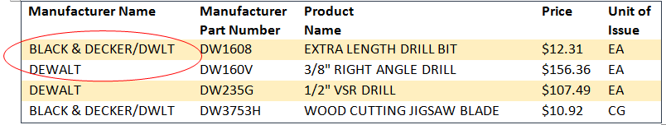

Table 1 – Sample Vendor Data Submitted to GSA

Note that even within the supplier’s own catalog, the same manufacturer name is referred to in different ways. For example, we see that two different names are used to represent Black & Decker’s Dewalt brand: BLACK & DECKER/DWLT, and DEWALT. To expand the perspective, XSB is aware of more than one hundred variations of the Black and Decker name across all of the different catalogs available on GSA Advantage!, and more than fifty variations on DoD EMALL, another Government hosted eCommerce portal. Additionally, part number representations differ from supplier to supplier; DEWDW235G and BLADW235G are different ways to identify the part DW235G. Another layer of complexity is added when suppliers provide their internal catalog numbers in the fields designated for a Manufacturer part number.

XSB’s patented Master Data File (MDF) engine was developed to standardize the differences in manufacturer name, part number and brand representations that complicate part search, selection and comparison. The Master Data File engine is able to find identical products described differently across the supply chain. This is done via an automated process using proprietary algorithms, statistical matching, knowledge of company brands, affiliations, and other associations.

The MDF captures, maintains and leverages a single, trusted, accurate, current and complete view of part data found throughout the organization, its customers, and its network of suppliers. It provides a consistent and standardized set of identifiers and enriched product attributes that describe the core entities of the supply chain: customers, products, contracts and suppliers. Each entity appears once and all references are to that standardized entity identifier. The MDF enables us to identify and analyze identical parts. This solution has enabled our customers to optimize part selection and price, reduce interruptions due to obsolescence, and increase supply chain velocity.

In addition to the MDF engine, XSB maintains a global item master database of more than 90 Million parts. This database contains rich information on commercial parts, suppliers, logistics, price and regulatory data. Data is aggregated from multiple Government databases (DoD EMALL, GSA Advantage! and NASA SEWP) and Web based commercial sources; this data is presently updated bi-monthly. This item master is the backbone of many of our software solutions, including Price Point® and Warwick®.

III – Proposed Solutions:
Warwick® is a web based tool designed to provide suppliers with access to a wealth of research and custom analytics that help them identify and track their competitors, maximize sales opportunities, expand their product lines, and manage prices more effectively.

Warwick’s suite of custom reports includes:
• Sales and performance reports that quantify the addressable market
• Customized price evaluation and optimization reports
• National stock number cross referencing
• Green product identification
• Top selling items by product category
• Identification of competitor products and pricing by contract

Price Point® is a web based application used by Procurement and Contracting Officers both commercially and in the Federal government to support price research and the determination of fair prices for commonly purchased parts. This unique tool enables users to perform a horizontal price analysis searching across product and pricing data on tens-of-millions parts on government contract and in the wider web based supply chain. Each analyzed SKU receives a risk score; an estimate of the probability that the proposed price is not competitive when evaluated against prices for the same part from other vendors. This risk score is calculated by comparing the offer price against a statistical model that is built using the existing prices. Reports also provide a supporting price evidence at the SKU level.

As both Warwick® and Price Point® are automated tools, they greatly reduce user Time to Knowledge; a catalog of 10K SKUs can typically be evaluated in about 1 hour.

IV – License Options and Pricing:
XSB licenses Warwick® and Price Point® on an annual subscription basis.

- XSB proposes to provide Government Contract Services, Inc. a single (1) seat license to Warwick® for an annual license fee of $15,000. Government Contract Services, Inc. may use this license to obtain sales, product, and pricing data in support of their GSA MAS clients.

- XSB proposes to provide Government Contract Services, Inc. a single (1) seat license to Price Point® for an annual license fee of $25,000. Government Contract Services, Inc. may use this license to obtain pricing data in support of their GSA MAS clients. However, usage will be limited to a total of five (5) jobs/price reports per day during the license Term.

